Wave Interference
- Open the Java Applet at: http://www.phy.ntnu.edu.tw/~hwang/doubleSlit/doubleSlit.html
- 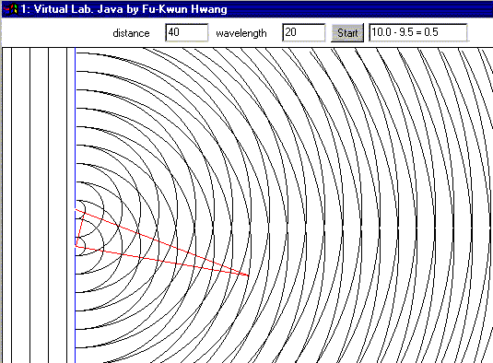Click the "Start" button and watch the animation. You should be able to see a series of ever-increasing concentric circles leaving each of two point sources. Change: wavelength to 20 and distance between slits to 40, then press "Start" again. If you click the right mouse, the animation is suspended until you click it again.
Nodal Line
Antinodal Line
- Regions where wave crests from one slit meet and cancel troughs from the other slit (destructive interference) are called nodal lines. These lines of undisturbed material curve out from between the two slits. They look fairly uniformly grey on the screen. How many can you see? Is the pattern symmetrical?
Antinodal Line
Nodal Line
- The orange lines measure distances from both slits in numbers of wavelengths as shown in the textbox at the top of the applet. Record three sets of measurements along each nodal line in the table below.
Note: nodal lines are numbered 1, 2, 3, etc from the centre towards each side.
Nodal Line | Distance from 1st slit | Distance from 2nd slit | Path difference
- What pattern do you notice?

- Regions where both wave crests (and then both troughs) arrive at the same instant (constructive interference) are called antinodal lines. These areas of very disturbed material curve out from between the two slits. How many can you see? Is the pattern symmetrical?
Note: antinodal lines are numbered “0” in the centre and then 1, 2, 3, etc. to the sides.
- Record three sets of measurements along each antinodal line in the table below
Antinodal Line | Distance from 1st slit | Distance from 2nd slit | Path difference
- What pattern do you notice?

- Open three new windows by clicking the first start button three more times. Resize so you can see all four at once. Change: wavelength to 20 in each. Set distance between slits to 60,80 and 100 respectively. Hit the "Start" button inside each window. Right click to suspend animation.
- Use these tables to help you find mathematical rules that connect:
- the number of nodal lines and the ratio of distance between slits to wavelength.
- the number of a nodal line or antinodal line and the path difference in wavelengths
Ratio of distance between slits to wavelength (d/λ) | Number of nodal lines (n)

General Rule:

Nodal Line  (n) | Path Difference |  | Antinodal Line  (n) | Path Difference
n = 1 | …λ |  | n = 0 | …λ
n = 2 | …λ |  | n = 1 | …λ
n = 3 | …λ |  | n = 2 | …λ
n = 4 | …λ |  | n = 3 | …λ
n = 5 | …λ |  | n = 4 | …λ
General Rule:  PD = |  |  | General Rule:  PD =

